How to apply for graduate school classes
(대학원 수강신청 방법)
- Log in to the integrated information system during the course registration period.
(Only, Inter Explore. Only Korean.
Please using the Translator: https://papago.naver.com/)
- Left Tab: Graduate Administration(대학원행정) – Course(수강) - Course Processing(수강처리) - Course Application(수강신청)
- Search for the desired class, check it, and apply for the class.
If you choose a department, you can check the classes held in the department.
(Communication: 언론정보학과)
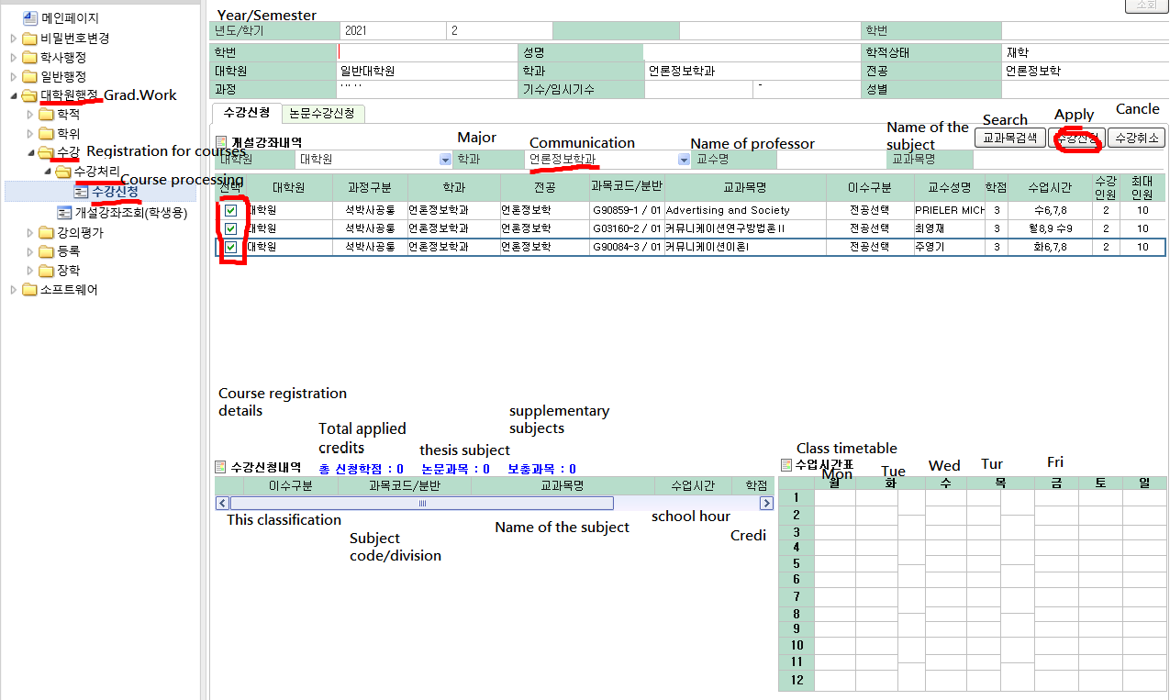

 |  | Class schedule frame
50-minute class | 월Mon |  | 화(Tue) |  | 수Wed |  | 목(Tur.) |  | 금Fri |  |  | 75-minute class
0Class  08:00~  08:50 |  |  |  |  |  |  |  |  |  |  |  | 0 Class  08:00~  08:50
1Class  09:00~  09:50 |  |  |  |  |  |  |  |  |  |  |  | A Class  09:00~  10:15
2Class
10:00~
10:50
B Class
10:30~
11:45
3Class
11:00~
11:50
4교시  12:00~  12:50 |  |  |  |  |  |  |  |  |  |  |  | C Class  12:00~  13:15
5Class
13:00~
13:50
D Class
13:30~
14:45
6Class
14:00~
14:50
7Class  15:00~  15:50 |  |  |  |  |  |  |  |  |  |  |  | E Class  15:00~  16:15
8Class
16:00~
16:50
F Class
16:30~
17:45
9Class
17:00~
17:50
10Class  18:00~  18:50 |  |  |  |  |  |  |  |  |  |  |  | G Class  18:00~  19:15
11Class
19:00~
19:50
H Class
19:30~
20:45
12Class
20:00~
20:50

